**Strings Assignment**

In this assignment, you will create a Spring Boot application that will respond with some hard coded text for two routes.

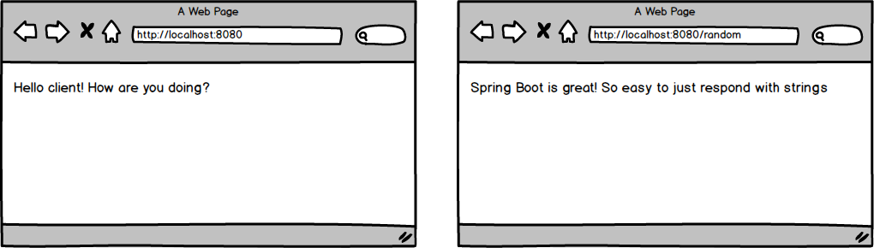

Topics:

* New Spring Boot project
* Annotations
* Dependencies
* Methods

Tasks:

* Create a brand new Spring Boot application
* When a user visits the root route, have a nice message appear for the client.
* When a user visits the '/random' route, have a nice message about Spring Boot appear for the client.